**Testing Report**

**User Input Testing: -**

The User Input Test Cases are included in the TestSpecifications.tsl. Generated using the TSLgenerator.

1. **Unit Testing :-**

|  |  |  |
| --- | --- | --- |
| Test Case no. | Input | Testing Result |
| 1. | Searching For a video File.  The Exact Name of the File i.e. y2mate.com_-_Nature_Beautiful_short_video_720p_HD_360p  Name typed in the search bar :  y2mate.com_-_Nature_Beautiful_short_video_720p_HD_360p  And then Downloading the file. | File displayed as expected. Video was playing fine.  Download was successful. |
| 2. | Searching For a video File. Using the Exact Name of the File i.e.  y2mate.com_-_Nature_Beautiful_short_video_720p_HD_360p  Name typed in the search bar:  Nature  And then Downloading the file. | File displayed as expected. Video was playing fine.  Download was successful. |
| 3. | Searching For a video File.  The Exact Name of the File i.e.  Ch103_slset_1.pdf  Name typed in the search bar:  Ch103_slset_1.pdf  And then Downloading the file. | File displayed as expected.  Download was successful. |
| 4. | Searching For a video File.  The Exact Name of the File i.e.  Ch103_slset_1.pdf  Name typed in the search bar:  CH103  And then Downloading the file. | File displayed as expected.  Download was successful. |
| 5. | Searching for a random file not present in Google Drive.  Example a name like :  fwaffrsreag | No error  There was no output displayed. No message displayed. |

1. **Integration Testing:-**

After Integrating with the main Branch, testing again for the same test Cases as before. Test Cases are present in the TestSpecifications.tsl file.

|  |  |  |
| --- | --- | --- |
| Test Case no. | Input | Testing Result |
| 1. | Searching For a video File.  The Exact Name of the File i.e. y2mate.com_-_Nature_Beautiful_short_video_720p_HD_360p  Name typed in the search bar :  y2mate.com_-_Nature_Beautiful_short_video_720p_HD_360p  And then Downloading the file. | File displayed as expected. Video was playing fine.  Download was successful. |
| 2. | Searching For a video File. Using the Exact Name of the File i.e.  y2mate.com_-_Nature_Beautiful_short_video_720p_HD_360p  Name typed in the search bar:  Nature  And then Downloading the file. | File displayed as expected. Video was playing fine.  Download was successful. |
| 3. | Searching For a video File.  The Exact Name of the File i.e.  Ch103_slset_1.pdf  Name typed in the search bar:  Ch103_slset_1.pdf  And then Downloading the file. | File displayed as expected.  Download was successful. |
| 4. | Searching For a video File.  The Exact Name of the File i.e.  Ch103_slset_1.pdf  Name typed in the search bar:  CH103  And then Downloading the file. | File displayed as expected.  Download was successful. |
| 5. | Searching for a random file not present in Google Drive.  Example a name like :  fwaffrsreag | No error  There was no output displayed. No message displayed. |

**Testing Django’s URLs mapping to Views function**

**Unit Test**

* urls.py

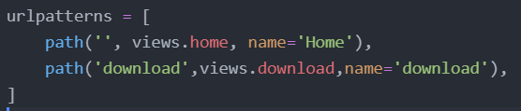

* + Home – home page contains search box and result
  + Download – download the selected file
* test.py script file is in test directory of Gdrive API documentation
* Result

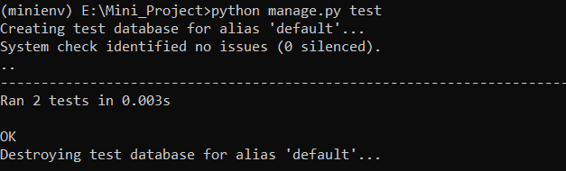

**Integration Test**

* urls.py

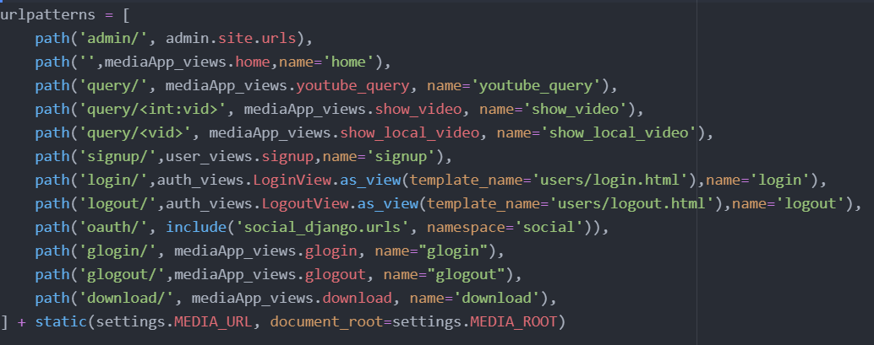

Gdrive team is using 5 urls from the above – youtube_query, show_local_video, glogin, glogout, download

Result of these 5 urls is given below

* + youtube_query – result from google drive is concatenated to youtube result
  + show_local_video – play the selected video
  + Glogin – login for gmail and give permission for accessing gdrive
  + Glogout – logout from gmail
* test.py script file is in test directory of Gdrive API documentation
* Result

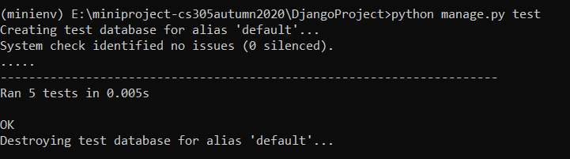

**Testing Documentation**

* **User Input testing**

Test cases are generated from TSL generator and it is tested manually by typing in search box.

* **URL mapping of Django project**
  + Copy the .py test script file (integration_test.py for integrated project) in the main project folder of Django (mediaApp directory).
  + Run the command

‘python manage.py test’